# **Person Cheque**

This document gives technical aspect on Cheque Person program.

## **Objective**

Primary objective is to get name and amount from user and display entered name and amount in words.

## **Technology used**

To achieve this, a project is developed in

* .NET 4.5.2
* ASP.NET 4.5
* Visual Studio 2015
* Web Service

## **URL**

Cheque application is running on URL <http://localhost:60325/personcheque.aspx>.

## **Architecture**

It’s a three layered architecture which represents “***Separation of Concern***” i.e. each layer can be change its core logic without modifying or affecting other layers.

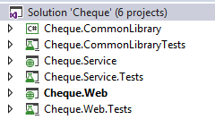

Test cases projects are also developed for each layer’s project.

**Cheque.Web** – It’s our web project which get the data, do the validations and pass the data to Webservice. On receiving, browser displays the appropriate result.

**Cheque.WebService** – It’s a business layer which receive the request from clients and return the result.

**Cheque.CommonLibrary** – This library contains actual logic to convert currency amount to words.

|  |
| --- |
|  |

## **Cheque Person Project**

Cheque Person project code is available in ***Cheque.Web*** ASP.NET project as shown in below image

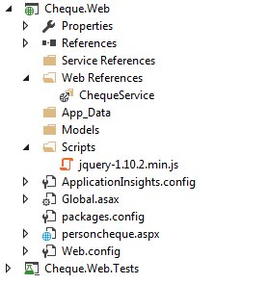

## **Cheque Service**

Cheque person is using web service ***Calculation.asmx*** to get the amount in words. It resides in *Cheque.Service* project.

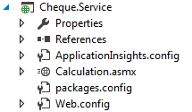

## **Web methods**

This web service contains a web method which accept a decimal number and return amount in words.

public string ConvertNumberToWord(decimal amount)

It’s running on URL <http://localhost:54168/Calculation.asmx>

## **Config Keys**

Web service URL can be change from web.config file at

<setting name="Cheque_Web_ChequeService_Calculation" serializeAs="String">

<value>http://localhost:54168/Calculation.asmx</value>

</setting>

## **Screens**

### **Person Cheque**

User should enter name and amount on this screen.

Validations are applied on both client side and server side for name and amount field.

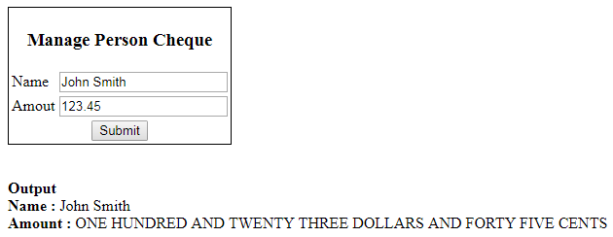

### **Actions**

* **Submit** – System should print name and amount in words as shown in above image.